

**Ministry of Communications and Information Technology (MCIT)**

**Digital Egypt Pioneers Initiative – DEPI**

**Round 3 (June – December 2025)**

**Information Security Analyst Track**

**(MNF3_ISS6_S1)**

**Graduation Project:**

**Blue Ants:**

**Mini Security Operations Center (SOC) Environment**

**Supervised by:**

**Eng: Muhammad Gamal**

**Prepared by:**

1. ***Ahmed Ehab Ibrahim Shalaby (Team leader)***
2. ***Ebrahim Ezzat Ahmed Briqaa***
3. ***Yousef Nabil Yousef Hagir***
4. ***Shahd Mostafa Ebrahim El Saidy***

**Acknowledgment**

I would like to express my deepest gratitude to our instructor, **Eng: Muhammad Gamal** for their continuous guidance, support, and constructive feedback throughout the development of this project. Their expertise and dedication played a significant role in helping us design, build, and refine our Mini Security Operations Center.

As the team leader of this project, I am proud to acknowledge the effort, commitment, and collaboration shown by my teammates:  
**Ebrahim Ezzat, Yousef Hagir, Shahd El Saidy.**  
Each member contributed with professionalism and enthusiasm, making the teamwork experience both productive and inspiring.

I thank my team for trusting my leadership and for working together to overcome challenges, perform testing, analyzing security events, and delivering a complete, high-quality SOC environment.

Finally, I extend my appreciation to the DEPI program and the creators of the open-source technologies we used—pfSense, Wazuh, Snort, DVWA, and Kali Linux—for providing the tools and knowledge that made this hands-on learning experience possible.

**Abstract**

This project presents the design and implementation of a fully functional Mini Security Operations Center (SOC) built within a segmented virtual environment. The system consists of three isolated network zones—SIEM, Victims, and Attacker—interconnected through a pfSense firewall configured with Snort IDS for intrusion detection and centralized log forwarding. The Wazuh SIEM platform, deployed on Ubuntu, serves as the core monitoring and correlation engine, receiving logs from pfSense, Windows, Linux, and DVWA servers through integrated Wazuh agents.

A series of controlled attack scenarios were executed from a dedicated Kali Linux machine, including RDP brute-force attempts, SQL injection, XSS, Nmap reconnaissance, and privilege abuse. The project demonstrates the complete SOC lifecycle: log ingestion, detection, correlation, triage, and reporting. All events were mapped to the MITRE ATT&CK framework to ensure structured threat analysis. The resulting SOC environment provides hands-on experience in enterprise-grade monitoring, use case development, and incident investigation, enabling a practical understanding of real-world security operations.

**Introduction**

Cybersecurity has become one of the most critical pillars in protecting modern organizations from evolving cyber threats. Security Operations Centers (SOCs) play a central role in monitoring environments, detecting attacks, and responding effectively. This project focuses on the design and implementation of a **Mini Security Operations Center (SOC)** that mirrors real-world enterprise SOC operations within a controlled virtualized lab environment.

The environment consists of a **segmented network architecture** divided into three main zones:

* **SIEM Network:** hosting the **Wazuh Manager** for centralized log collection, correlation, and alerting.
* **Victims Network:** containing a **Windows 10 endpoint** and a **DVWA** web application server.
* **Attacker Network:** a Kali Linux machine used to simulate offensive security scenarios and generate detectable events.

A pfSense firewall sits at the core of the environment, providing routing, DHCP, firewall enforcement, NAT, and network intrusion detection capabilities via **Snort IDS**. All machines forward their logs to the Wazuh SIEM, enabling centralized visibility across the entire infrastructure.

To validate the SOC’s effectiveness, the team executed a set of controlled attack scenarios including **RDP brute force attempts**, **SQL injection**, **Cross-Site Scripting (XSS)**,. Each scenario generated logs that were analyzed, correlated, and mapped to the **MITRE ATT&CK framework**, demonstrating the full lifecycle of threat detection and incident analysis.

This project provides practical, hands-on experience in SOC engineering and operations—covering log ingestion, threat detection, use case development, alert triage, and incident reporting. It serves as a foundation for understanding real-world SOC workflows and equips the team with essential defensive security skills needed in modern cybersecurity roles.

Table of Contents

CHAPTER 1 — SOC SETUP & LOG INGESTION 8

Summary Overview 8

VMs Installation Resources 9

Lab Architecture Overview 10

Network Segmentation Overview: 10

Traffic Flow Overview: 11

Host & VMware Configuration 12

Virtual Machines Deployment 13

1. pfSense Firewall 13

2. Ubuntu — Wazuh Manager 14

3. Windows 10 (Victim) 15

4. DVWA Server (Ubuntu) 16

5. Kali Linux (Attacker) 17

6: pfSense Firewall & NAT Configuration 18

7: Snort Installation 19

9: Install Wazuh Agents 20

10: Verification & Testing 21

11: Deliverables Checklist 21

12: Troubleshooting Reference 21

CHAPTER 2 — USE CASE DEVELOPMENT 22

1. SIEM Use Case Document: Correlated SQL Injection (NIDS + EDR) 22

1. Metadata 22

2. Use Case Overview 23

3. Threat Intelligence & Mapping 24

4. Technical Requirements 24

5. Detection & Correlation Logic 25

6. Alert & Triage Details 26

7. Validation & Testing 27

8. Incident Response Playbook 27

Screenshots 29

2. SIEM Use Case Document: Correlated XSS Attack (NIDS + EDR) 31

1. Metadata 31

2. Use Case Overview 32

3. Threat Intelligence & Mapping 33

4. Technical Requirements 33

5. Detection & Correlation Logic 35

6. Alert & Triage Details 36

7. Validation & Testing 36

8. Incident Response Playbook 37

Screenshots 38

3. SIEM Use Case Document: Correlated RDP Brute Force (NIDS + HIDS/EDR) 40

1. Metadata 40

2. Use Case Overview 40

3. Threat Intelligence & Mapping 41

4. Technical Requirements 41

5. Detection & Correlation Logic 43

6. Alert & Triage Details 44

7. Validation & Testing 44

8. Incident Response Playbook (SOP) 44

Screenshots 45

CHAPTER 3 — ALERT TRIAGE & INCIDENT ANALYSIS 49

2. SOC Triage Workflow 49

2.1 Initial Detection 49

2.2 Alert Enrichment 49

2.3 Cross-Layer Correlation 49

2.4 Timeline Reconstruction 50

2.5 MITRE Technique Mapping 50

2.6 Analyst Judgement 50

3. Use Case 1 – RDP Brute Force Alert Investigation 50

3.1 Alert Summary 50

3.2 Detailed Event Sequence 51

3.3 Evidence Collected 51

3.5 IOC Extraction 53

3.6 Analyst Assessment 53

4. Use Case 2 – SQL Injection Attack Investigation 54

4.1 Alert Summary 54

4.2 Timeline Reconstruction 55

4.3 Evidence Collected 55

4.4 IOC Extraction 56

4.5 Analyst Assessment 56

5. Use Case 3 – XSS Attack Investigation 57

5.1 Alert Summary 57

5.2 Evidence 58

5.3 Analyst Assessment 58

6. Chapter Summary 58

CHAPTER 4 — SOC REPORTING, KPIs & FINAL ASSESSMENT 59

1. Introduction 59

2. SOC Performance KPIs 59

2.1 Detection Coverage KPIs 60

2.2 Alert Quality KPIs 60

2.3 Performance KPIs 61

2.4 Operational Efficiency KPIs 61

3. Root Cause Analysis (RCA) 61

3.1 Incident Summary 61

3.2 Root Cause 62

3.3 Contributing Factors 62

3.4 Evidence Summary 62

3.5 Impact Assessment 62

3.6 Recommendations 63

4. MITRE ATT&CK Detection Coverage Report 63

5. SOC Maturity Assessment 63

6. System & Security Performance Monitoring 64

66

7. Recommendations for SOC Improvement 67

Short-Term Improvements 67

Long-Term Improvements 67

8. Executive Summary 67

# CHAPTER 1 — SOC SETUP & LOG INGESTION

(Full Expanded Version — Enterprise Grade, with Screenshot Placement Markers)

## Summary Overview

This represents **Week 1** of the **Digital Egypt Pioneers Initiative (DEPI)** Mini SOC build.  
The objective is to design and deploy a **small-scale Security Operations Center (SOC)** that collects, analyzes, and correlates security logs from multiple systems within a segmented virtual network.

The SOC is built on **VMware Workstation Pro** and consists of **five virtual machines**, connected through a **pfSense firewall** that provides routing, firewall, and IDS/IPS (Snort) capabilities.  
Each network segment — **SIEM**, **Victims**, and **Attacker** — is logically separated to simulate real-world enterprise environments.

All systems receive IP addresses dynamically via **pfSense DHCP**, and logs are centrally collected and analyzed by **Wazuh Manager**, which serves as the **SIEM** (Security Information and Event Management) platform.

**Machine Roles:**

| **Machine** | **Role** | **Description** |
| --- | --- | --- |
| **pfSense Firewall** | Network Gateway, Firewall & IDS | Routes traffic between networks, filters connections, and runs Snort for intrusion detection. Forwards logs to Wazuh. |
| **Wazuh Manager (Ubuntu)** | SIEM Server | Receives logs from pfSense, Windows, and Linux agents. Correlates events and generates alerts. |
| **Windows 10** | Victim Endpoint | Represents a user workstation. Runs the Wazuh agent to forward system and security logs. |
| **DVWA Server** | Victim Web Application Server | Hosts the “Damn Vulnerable Web Application” to simulate real-world web attack scenarios. |
| **Kali Linux** | Attacker System | Used to perform ethical hacking tests (e.g., scans, brute-force, SQLi, XSS) to trigger alerts and validate SOC functionality. |

## VMs Installation Resources

| **Virtual Machine** | **Base OS** | **Download Link** |
| --- | --- | --- |
| **pfSense** | pfSense | <https://www.pfsense.org/download/> |
| **Ubuntu** | Linux (for Wazuh) | <https://ubuntu.com/download/desktop> |
| **Windows 10 Pro** | Windows Endpoint | <https://www.microsoft.com/en-us/software-download/windows10> |
| **DVWA** | Vulnerable Web Application | <https://github.com/digininja/DVWA> |
| **Kali Linux** | Penetration Testing OS | <https://www.kali.org/get-kali/#kali-virtual-machines> |
| **Wazuh Installation Script** | SIEM Platform | <https://documentation.wazuh.com/current/quickstart.html> |

## Lab Architecture Overview

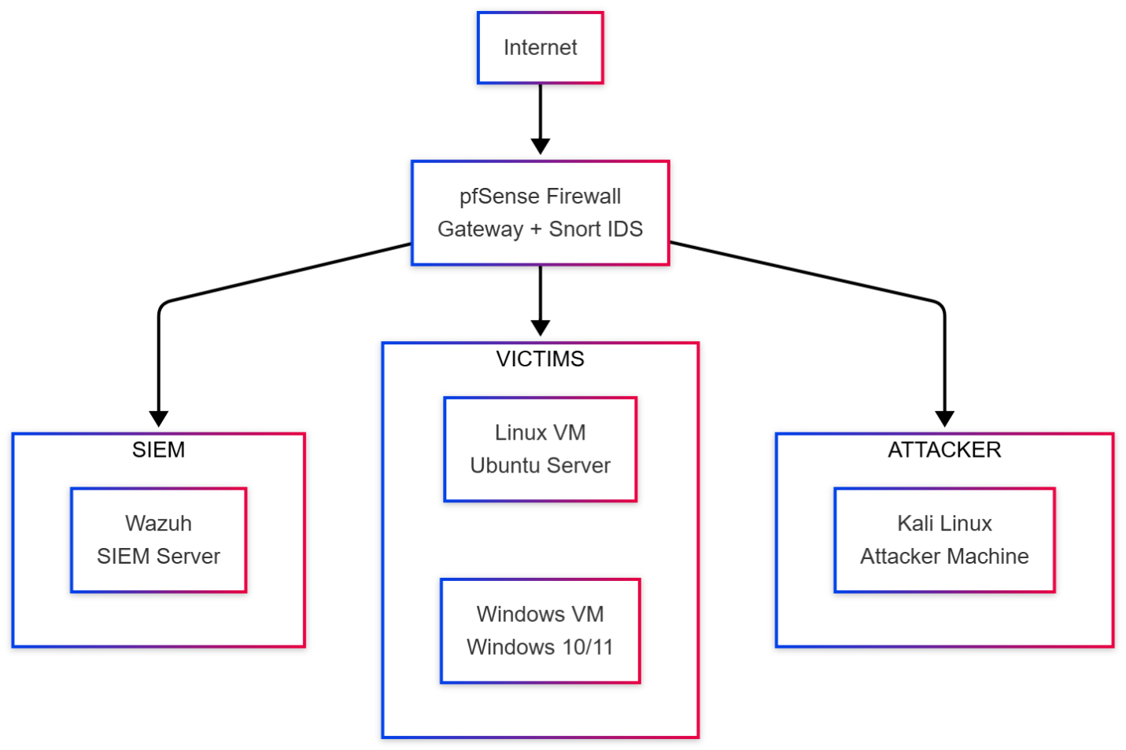

## Network Segmentation Overview:

| **Network** | **Purpose** | **Subnet** | **pfSense IP** | **Connected VMs** |
| --- | --- | --- | --- | --- |
| WAN | Internet / updates | DHCP | Dynamic | — |
| SIEM (LAN1) | Security monitoring | 40.40.40.0/24 | 40.40.40.1 | Wazuh Manager |
| Victims (LAN2) | Production targets | 20.20.20.0/24 | 20.20.20.1 | Windows 10, DVWA |
| Attacker (LAN3) | Red-team zone | 30.30.30.0/24 | 30.30.30.1 | Kali |

**Segmentation policy:**

* Victims → SIEM (allowed)
* Victims → Attacker (allowed)
* SIEM → Attacker (allowed)
* SEIM → Victims (allowed)
* Attacker → Victims (allowed)
* Attacker → SIEM (blocked)

## Traffic Flow Overview:

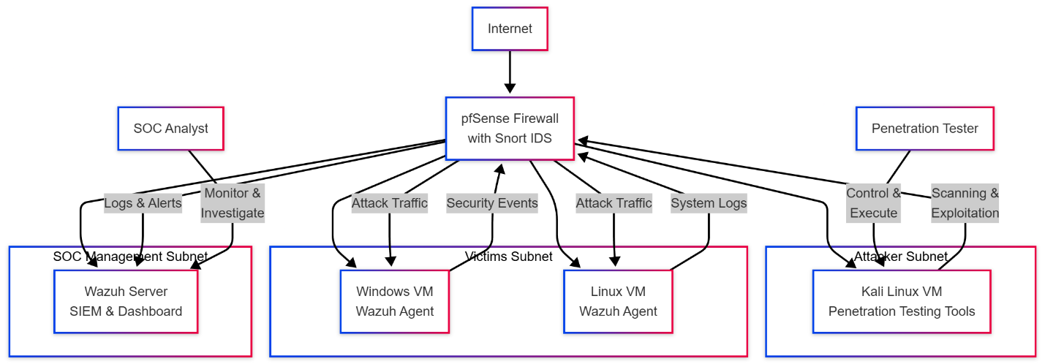

## Host & VMware Configuration

**Host:** Windows 11  
**Hypervisor:** VMware Workstation Pro  
**Installation:** <https://www.vmware.com/products/desktop-hypervisor/workstation-and-fusion>

**To Create Custom Networks:**

* 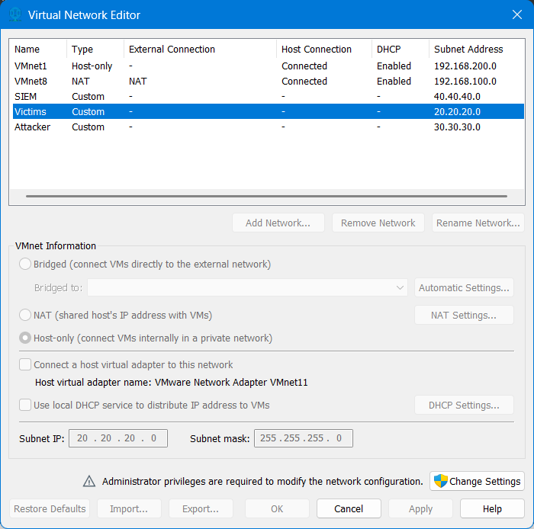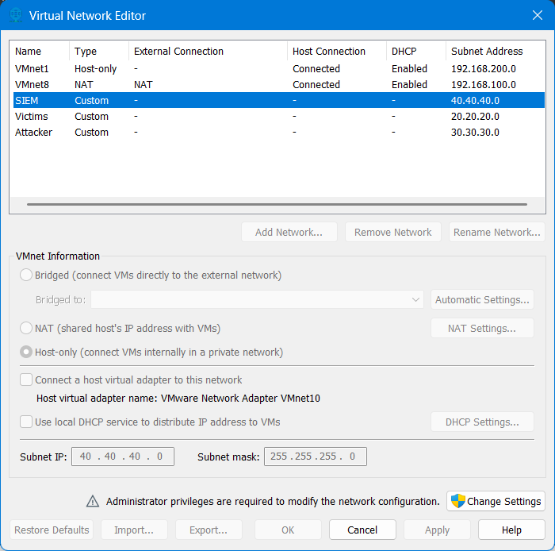In **Virtual Network Editor** → **Edit**:
* Add 3 virtual network cards with the same settings in screenshots

| **VMnet** | **Type** | **Purpose** | **Subnet** |
| --- | --- | --- | --- |
| vmnet0 | Bridged | pfSense WAN | Host Network |
| vmnet2 | Custom | SIEM (LAN1) | 40.40.40.0/24 |
| vmnet3 | Custom | Victims (LAN2) | 20.20.20.0/24 |
| vmnet4 | Custom | Attacker (LAN3) | 30.30.30.0/24 |

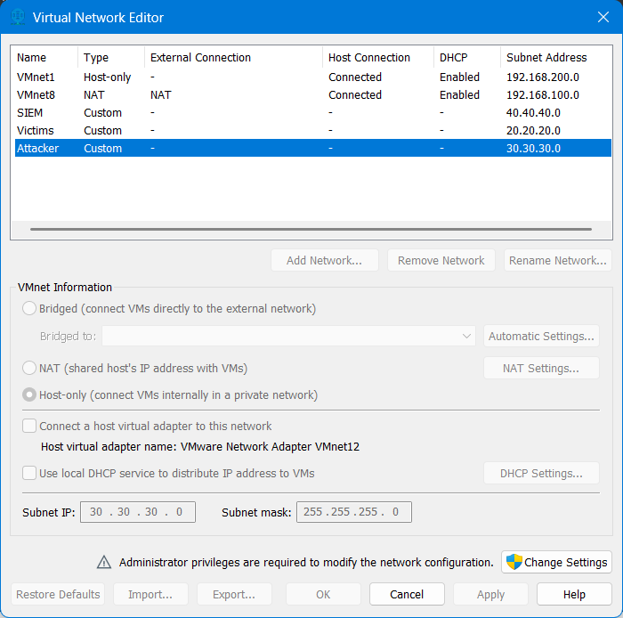

## Virtual Machines Deployment

### 1. pfSense Firewall

**ISO:** pfSense: <https://www.pfsense.org/download/>

**Steps:**

1. Create new VM → *FreeBSD 64-bit* → attach pfSense ISO.
2. Add 4 NICs (WAN + 3 LANs).
3. Boot installer → accept defaults → auto (UFS) partition → reboot.
4. Assign interfaces:

* WAN: DHCP
* LAN1: 40.40.40.1/24
* LAN2: 20.20.20.1/24
* LAN3: 30.30.30.1/24

1. Enable **DHCP server** for each LAN:

* LAN1: 40.40.40.50–100
* LAN2: 20.20.20.50–100
* LAN3: 30.30.30.50–100

6. Access the GUI using the Ip and credentials appeared at the end of installation

### 2. Ubuntu — Wazuh Manager

**Network:** LAN1 (SIEM) DHCP

**Steps:**

1. Install Ubuntu: <https://ubuntu.com/download/desktop>
2. Choose automatic (DHCP) network setup.
3. After rebooting, run in terminal: sudo apt update && sudo apt upgrade -y
4. Verify assigned IP, run: ip a
5. Install Wazuh: <https://documentation.wazuh.com/current/quickstart.html>
6. Access the GUI using the Ip and credentials appeared at the end of installation

### 3. Windows 10 (Victim)

**Network:** LAN2 (Victims) — DHCP

* Install Windows normally: <https://www.microsoft.com/en-us/software-download/windows10>
* Connect to pfSense LAN2 network, verify DHCP-assigned IP (ipconfig).
* Test connectivity to pfSense and Wazuh.

### 4. DVWA Server (Ubuntu)

**Network:** LAN2 (Victims) — DHCP

Install LAMP stack + DVWA:

* sudo apt update
* sudo apt install apache2 mysql-server php php-mysqli git -y
* cd /var/www/html
* sudo git clone https://github.com/digininja/DVWA.git
* sudo chown -R www-data:www-data DVWA
* sudo systemctl enable --now apache2 mysql
* Open http://<DVWA-IP>/DVWA

### 5. Kali Linux (Attacker)

**Network:** LAN3 (Attacker) — DHCP

* Install from ISO: [https://www.kali.org/get-kali/#kali-virtual-machines](https://www.kali.org/get-kali/%23kali-virtual-machines)
* Confirm IP assignment using ip a.
* Test ping to pfSense and Victims network.

### 6: pfSense Firewall & NAT Configuration

* A screenshot of a computer

  AI-generated content may be incorrect.**NAT:** Automatic mode
* **Firewall Rules:**
  + LAN1 (SIEM): Allow outbound
  + LAN2 (Victims): Allow SIEM + WAN
  + LAN3 (Attacker): Allow Victims, Block to SIEM, Allow to WAN

**Configure pfSense Remote Syslog → Wazuh**

* Navigate to **Status → System Logs → Settings → Remote Logging Options**
* Enable “Send log messages to remote syslog server.”
* Server: <Wazuh-IP>
* Port: 514 UDP
* Categories: Everything [All Logs]

### 7: Snort Installation

* Install via **System → Package Manager → Snort**
* Add interfaces (WAN + Victims)
* Enable “Send Alerts to System Log”

### 9: Install Wazuh Agents

**Follow Documentation:**

**Linux (DVWA) :** <https://documentation.wazuh.com/current/installation-guide/wazuh-agent/wazuh-agent-package-linux.html>

**Windows:** <https://documentation.wazuh.com/current/installation-guide/wazuh-agent/wazuh-agent-package-windows.html>

### 10: Verification & Testing

1. **Connectivity Tests:** Ping & verify DHCP leases.
2. **pfSense Log Flow:** Generate login and rule events.
3. **Snort Alerts:** Run nmap <DVWA-IP> from Kali, verify alerts in Wazuh.
4. **Agent Logs:** Trigger failed login or file changes, confirm detection.

### 11: Deliverables Checklist

| **Item** | **Description** |
| --- | --- |
| SOC Diagram | DHCP-based topology diagram |
| Firewall Rules | pfSense rules screenshots |
| Snort Config | “Send alerts to syslog” proof |
| Wazuh Dashboard | Log and alert evidence |
| Screenshots | As listed |
| Snapshots | post_pfSense, post_Wazuh, post_Agents |

### 12: Troubleshooting Reference

| **Problem** | **Check** |
| --- | --- |
| DHCP not assigning | Verify each LAN DHCP server enabled |
| No pfSense logs in Wazuh | Ensure UDP 514 open and ossec file |
| Agents not registering | Check UDP 1514 and firewall |
| Snort alerts missing | Confirm syslog export |
| Dashboard access issues | Allow ports 443/5601 |

# CHAPTER 2 — USE CASE DEVELOPMENT

***(Attack Scenarios, Execution, Detection, and Correlation)***

The purpose of this chapter is to document the offensive security use cases executed in the Mini-SOC environment, along with their detection mechanisms, logs generated, MITRE ATT&CK mappings, and correlation results within the Wazuh SIEM platform.

Each use case follows a consistent enterprise-grade structure:

1. **Use Case Overview**
2. **Objective & Purpose**
3. **Prerequisites & Environment Conditions**
4. **Execution Steps (Attacker Actions)**
5. **Telemetry Generated (Network + Endpoint)**
6. **Detection Logic (Snort + Wazuh)**
7. **MITRE ATT&CK Mapping**
8. **Screenshots to include**

## 1. SIEM Use Case Document: Correlated SQL Injection (NIDS + EDR)

### 1. Metadata

| **Field** | **Details** |
| --- | --- |
| **Use Case ID** | UC-SQLI-2025-001 |
| **Use Case Title** | **Correlated SQL Injection (SQLi) Attempt (NIDS + EDR)** |
| **Priority / Severity** | **High** (Correlated Level 10 Alert) |
| **Status** | Production |
| **Author** | Ebrahim Ezzat |
| **Date Created** | 2025-11-01 |
| **Last Updated** | 2025-11-12 |

### 2. Use Case Overview

**2.1. Description**

This case detects a confirmed SQL Injection (SQLi) attack by correlating two separate detection mechanisms:

1. **Network Intrusion Detection (NIDS):** A Snort alert that identifies a malicious SQLi pattern in network traffic.
2. **Endpoint Detection and Response (EDR):** A Wazuh agent rule that identifies the same SQLi pattern in the target web server's access logs.

When both the network *and* the host server log an SQLi attempt from the same source within a short time frame, this use case triggers a high-severity alert, indicating   
a high-fidelity, confirmed attack.

**2.2. Objective**

* To detect active SQL Injection attempts against the "DVWA" web application (20.20.20.2).
* To significantly **reduce false positives** by requiring both NIDS and EDR validation.
* To elevate the alert severity from a standard "attempt" (Level 6) to a "confirmed correlated attack" (Level 10) for immediate SOC triage.

**2.3. Threat Scenario**

An external attacker (e.g., 30.30.30.2) uses a tool (like sqlmap, burp suite, or a simple browser) to send a malicious HTTP GET request to the DVWA server (20.20.20.2). This request contains SQLi payloads (e.g., ...id=%27+or+1%3D1--) in the URL, attempting to bypass authentication or exfiltrate data.

### 3. Threat Intelligence & Mapping

**3.1. MITRE ATT&CK**

* **Tactic:** TA0001 - Initial Access
* **Technique:** T1190 - Exploit Public-Facing Application

**3.2. Compliance Mapping**

* **PCI-DSS:** 6.5, 11.4, 6.5.1
* **GDPR:** IV_35.7.d
* **NIST 800-53:** SA.11, SI.4
* **TSC:** CC6.6, CC7.1, CC8.1, CC6.1, CC6.8, CC7.2, CC7.3

### 4. Technical Requirements

**4.1. SIEM**

* **Platform:** Wazuh (Manager, Indexer, Dashboard)

**4.2. Data Sources**

1. **NIDS (Network):**
   1. **Source System:** pfSense Firewall with Snort
   2. **Logs:** Snort Alerts (forwarded via syslog to Wazuh Manager).
2. **EDR (Host):**
   1. **Source System:** DVWA Web Server (20.20.20.2)
   2. **Agent:** Wazuh Agent installed.
   3. **Logs:** Apache Access Log (/var/log/apache2/access.log), Apache Error Log (/var/log/apache2/error.log).

**4.3. Wazuh Components (Decoders & Rules)**

* **Custom Snort Decoder:**

|  |
| --- |
| <decoder name="snort">  <prematch>DVWA SQLi attempt</prematch>  </decoder> |

* **Custom Snort Rule (NIDS-based):**

|  |
| --- |
| <rule id="100900" level="6">  <decoded_as>snort</decoded_as>  <match>DVWA SQLi attempt - HTTP URI match</match> <description>Snort Alert — DVWA SQL Injection attempt detected</description> <group>snort,sql_injection,attack,local,sqlinjection</group>  </rule> |

* **Standard Web Log Rules (EDR):**

|  |
| --- |
| <group name="web,accesslog,">  <rule id="31100" level="0"> <category>web-log</category> <description>Access log messages grouped.</description> </rule> |

|  |
| --- |
| <rule id="31164" level="6">  <if_sid>31100</if_sid> <url>=%27|select%2B|insert%2B|%2Bfrom%2B|%2Bwhere%2B|%2Bunion%2B</url>  <description>SQL injection attempt.</description>  <group>attack,sqlinjection,attack,...</group>  </rule> |

* **Correlation Rule (Parent Rule):**

|  |
| --- |
| <rule id="100911" level="10" frequency="2" timeframe="120"> <if_matched_group>sqlinjection</if_matched_group> <global_frequency /> <description>Confirmed SQL Injection (Correlated NIDS + EDR)</description> <group>correlation,confirmed,sqlinjection,pci_dss_6.5,pci_dss_11.4,pci_dss_6.5.1,gdpr_IV_35.7.d,nist_800_53_SA.11,nist_800_53_SI.4,tsc_CC6.6,tsc_CC7.1,tsc_CC8.1,tsc_CC6.1,tsc_CC6.8,tsc_CC7.2,tsc_CC7.3,</group>  <mitre> <id>T1055</id> <id>T1190</id> </mitre>  </rule> |

### 5. Detection & Correlation Logic

This use case operates in three stages:

#### Stage 1: NIDS Detection (Snort Alert)

1. The attacker (30.30.30.2) sends the malicious payload.
2. The traffic passes through the pfSense firewall.
3. The **Snort Rule (sid:2000001)** matches the URI pattern (/DVWA/vulnerabilities/sqli/) and the payload (union, select, etc.).
4. Snort generates the alert: ... [1:2000001:2] DVWA SQLi attempt - HTTP URI match {TCP} 30.30.30.2: ANY -> 20.20.20.2:80
5. Wazuh ingests this log. The custom snort decoder parses it.
6. **Wazuh Rule 100900** fires (Level 6) because it matches the description text.
7. This alert is added to the **SQL injection** group.

#### Stage 2: EDR Detection (Apache Log)

1. The malicious request hits the DVWA server (20.20.20.2).
2. The Apache web server logs the request in /var/log/apache2/access.log:
3. 30.30.30.2 - - ... "GET /DVWA/vulnerabilities/sqli/?id=%27+or+1%3D1--&Submit=Submit HTTP/1.1" 500 ...
4. The Wazuh agent on DVWA reads this log line.
5. **Wazuh Rule 31164** fires (Level 6) because the url field contains a forbidden pattern (=%27 or %2Bunion%2B, etc.).
6. This alert is also added to the **sqlinjection** group.

**Stage 3: Correlation (Parent Rule)**

1. **Wazuh Rule 100911** is triggered.
2. Its logic is: frequency="2" and timeframe="120" for the group sqlinjection.
3. This means: "If **two** alerts from the sqlinjection group are seen within **120 seconds**, fire this rule."
4. Since one alert came from Snort (NIDS) and one from Apache (EDR), the condition is met as **[global_frequency]** Specifies that the events of all agents will be contemplated when using the frequency and timeframe options. By default, only the events generated by the same agent will be taken into account to increase the frequency counter for a rule.
5. A new, high-severity **Level 10** alert is generated with the description: **"Confirmed SQL Injection (Correlated NIDS + EDR)"**.

### 6. Alert & Triage Details

* **Alert Title:** Confirmed SQL Injection (Correlated NIDS + EDR)
* **Alert Rule ID:** 100911
* **Severity:** **High (Level 10)**
* **Key Fields for Triage:**
  + src_ip: (Attacker) 40.40.40.5
  + dst_ip: (Victim) 20.20.20.2
  + url.full: (Payload) /DVWA/vulnerabilities/sqli/?id=%27+or+1%3D1--&Submit=Submit
  + snort.msg: DVWA SQLi attempt - HTTP URI match
  + http.status_code: 500 (Indicates the server failed to process the bad syntax, confirming impact).
* **Fidelity:** **High.** This alert is a correlation from two different, reliable sources (network and host). It is almost certainly a **True Positive**.

### 7. Validation & Testing

#### Test Scenario:

* 1. From the Kali machine (30.30.30.2), open a web browser.
  2. Navigate to the DVWA SQLi page: http://20.20.20.2/DVWA/vulnerabilities/sqli/
  3. In the "User ID" input box, type the payload ' or 1=1-- and click "Submit".
  4. Alternatively, send the full GET request via the browser bar or curl: curl <http://20.20.20.2/DVWA/vulnerabilities/sqli/?id=%27+or+1%3D1--&Submit=Submit>

#### Expected Outcome:

* + 1. Within the Wazuh dashboard, you will first see two (Level 6) alerts: one from Snort (Rule 100900) and one from web-log (Rule 31164).
    2. Within 120 seconds, a single **Level 10** alert (Rule 100911) will appear, confirming the correlation.

### 8. Incident Response Playbook

#### 1. Triage (Immediate)

* Acknowledge the Level 10 alert (Rule 100911). This is a high-priority event.

#### 2. Investigation

1. Identify the **Attacker IP** (src_ip) and **Victim Server** (dst_ip) from the alert.
2. Review the correlated alerts (the "children" of the 100911 alert).
   * Confirm the Snort alert message.
   * Confirm the Apache access.log and inspect the url.full field to see the exact payload used.
3. Check the Apache error.log for the same timeframe. Look for database errors (e.g., mysqli_sql_exception: You have an error in your SQL syntax) which further prove the attack hit the application's database layer.
4. Check access.log for *subsequent* activity from the src_ip. Did they receive a 200 OK? Did they try to access other pages?

#### 3. Containment (Immediate)

1. **Action:** Immediately block the **Attacker IP** (30.30.30.2) on the pfSense firewall to prevent further attacks.
2. **Action:** If the investigation shows the attacker successfully logged in or exfiltrated data, escalate to the Tier 2 team to isolate the web server (20.20.20.2) from the rest of the network.

#### 4. Eradication & Recovery

* Notify the Web Application Team and/or Development Team. Provide them with the url.full payload and the vulnerable page (/DVWA/vulnerabilities/sqli/).
* The vulnerability on the web application must be patched.
* Audit the database for any unauthorized modifications, new user accounts, or data deletion.

#### 5. Escalation & Reporting

* Escalate to the SOC Lead and Incident Response (IR) Team.
* Document all findings and actions taken in the incident ticket.

### Screenshots

1. **A screenshot of a computer

   AI-generated content may be incorrect.Snort Rule**
2. **Decoder for snort SQLi log**

1. **Logs in archive file (EDR and IDS)**
2. **EDR Rules**

1. **A screen shot of a computer code

   AI-generated content may be incorrect.Snort rule**
2. A close-up of a person

   AI-generated content may be incorrect.**Correlation rule**
3. **Alerts in Wazuh Dashboard**

## 2. SIEM Use Case Document: Correlated XSS Attack (NIDS + EDR)

### 1. Metadata

| **Field** | **Details** |
| --- | --- |
| **Use Case ID** | UC-WAZ-002 |
| **Use Case Title** | Correlated Reflected XSS Attack (NIDS + EDR) |
| **Priority / Severity** | High (Correlated Level 10 Alert) |
| **Status** | Production |
| **Author** | Ebrahim |
| **Date Created** | 2025-11-08 |
| **Last Updated** | 2025-11-12 |

### 2. Use Case Overview

#### 2.1. Description

**This case detects a high-confidence Reflected Cross-Site Scripting (XSS) attack. It correlates two distinct signals:**

* NIDS (Network): A Snort alert (sid:2000002) identifies a known XSS payload (e.g., <script>, onload=) in transit towards the DVWA web server.
* EDR (Host): The Wazuh agent monitoring the DVWA server's logs identifies that the same malicious request was successfully processed by the web server and returned an HTTP 200 OK status code.

#### 2.2. Objective

* To detect active XSS attempts against the DVWA vulnerability page (/DVWA/vulnerabilities/xss_r/).
* To dramatically increase alert fidelity by confirming the server's response. An HTTP 200 OK response to an XSS payload strongly implies the payload was "reflected" back to the user, confirming the vulnerability.
* To escalate the alert from a simple "attempt" (Level 6) to a "confirmed correlated attack" (Level 10) requiring immediate investigation.

#### 2.3. Threat Scenario

An external attacker (30.30.30.2) crafts a malicious URL containing a JavaScript payload and sends it to a victim (or tests it themselves). The request, .../xss_r/?name=<script>alert("xss")</script>, is sent to the DVWA server (20.20.20.2). The server-side script insecurely takes the name parameter and renders it back on the HTML page, causing the browser to execute the attacker's script.

### 3. Threat Intelligence & Mapping

#### 3.1. MITRE ATT&CK

* Tactic: TA0001 - Initial Access
* Technique: T1190 - Exploit Public-Facing Application
* Sub-Technique: T1059.007 - JavaScript/JScript (referenced by the underlying EDR rule 31105)

#### 3.2. Compliance Mapping

* PCI-DSS: 6.5, 11.4, 6.5.7
* GDPR: IV_35.7.d
* NIST 800-53: SA.11, SI.4
* TSC: CC6.6, CC7.1, CC8.1, CC6.1, CC6.8, CC7.2, CC7.3

### 4. Technical Requirements

#### 4.1. SIEM

* Platform: Wazuh (Manager, Indexer, Dashboard)

#### 4.2. Data Sources

1. **NIDS (Network):**
   1. Source System: pfSense Firewall with Snort
   2. Logs: Snort Alerts (forwarded via syslog).
2. **EDR :**
   1. Source System: DVWA Web Server (20.20.20.2)
   2. Agent: Wazuh Agent installed.
   3. Logs: Apache Access Log (/var/log/apache2/access.log).

#### 4.3. Wazuh Components (Decoders & Rules)

* **Custom Snort Decoder:**

|  |
| --- |
| <decoder name="snortxss">  <prematch>DVWA XSS attempt</prematch>  </decoder> |

* **Snort Alert Rule:**

|  |
| --- |
| <rule id="100901" level="6">  <decoded_as>snortxss</decoded_as>  <match>DVWA XSS attempt - HTTP URI match</match>  <description>Snort Alert — DVWA XSS attempt detected</description>  <group>snort,xss,attack,local</group>  </rule> |

* **EDR Alert Rules:**

|  |
| --- |
| <rule id="31105" level="6">  <if_sid>31100</if_sid>  <url>%3Cscript|%3C%2Fscript|script>|script%3E|SRC=javascript|...</url>  <description>XSS (Cross Site Scripting) attempt.</description>  <group>attack,xss...</group>  </rule> |

|  |
| --- |
| <rule id="31106" level="6" overwrite="yes">  <if_sid>31103, 31104, 31105</if_sid> <id>^200</id> <description>A web attack returned code 200 (success).</description>  <group>attack,xss,...</group>  </rule> |

* **Correlation Rule (Parent Rule):**

|  |
| --- |
| <rule id="100912" level="10" frequency="2" timeframe="120">  <if_matched_group>xss</if_matched_group>  <global_frequency/>  <description>Confirmed XSS Attack (Correlated NIDS + EDR)</description>  <group>correlation,confirmed,xss,attack,local</group>  </rule> |

### 5. Detection & Correlation Logic

**This use case's logic is highly effective because it confirms *success*, not just *intent*.**

**Stage 1: Snort Detection (The Intent)**

* Attacker (30.30.30.2) sends the GET request with the XSS payload.
* Snort (sid:2000002) inspects the traffic and matches the payload pattern (<script> or %3Cscript).
* Snort generates the alert: ... [1:2000002:1] DVWA XSS attempt - HTTP URI match {TCP} 30.30.30.2:56752 -> 20.20.20.2:80
* Wazuh ingests this, the snortxss decoder parses it, and Rule 100901 fires (Level 6).
* This first alert is added to the xss group.

**Stage 2: EDR Detection (The Success)**

* The malicious request hits the DVWA server (20.20.20.2).
* Apache processes the request and logs it to access.log:

30.30.30.2 - - ... "GET /DVWA/vulnerabilities/xss_r/?name=%3Cscript%3E... HTTP/1.1" 200 1859 ...

1. The Wazuh agent reads this log line.
2. First, the child rule 31105 (XSS attempt) fires because the URL contains %3Cscript.
3. Immediately after, the parent rule 31106 (Attack Success) checks its conditions.
   1. if_sid condition is met (because 31105 fired).
   2. id condition (^200) is met (because the log line explicitly shows HTTP 200).
4. Rule 31106 fires (Level 6) and overwrites the 31105 alert.
5. This second, more specific alert is also added to the xss group.

**Stage 3: Correlation (The Confirmation)**

1. Rule 100912 is triggered because its if_matched_group="xss" condition is met.
2. The rule's logic (frequency="2" timeframe="120") is now evaluated.
3. It finds two alerts in the xss group within 120 seconds:
   1. Alert 1: 100901 (Snort NIDS)
   2. Alert 2: 31106 (EDR 200 OK)
4. The condition is met. A new, high-severity Level 10 alert is generated: "Confirmed XSS Attack (Correlated NIDS + EDR)".

### 6. Alert & Triage Details

* **Alert Title:** Confirmed XSS Attack (Correlated NIDS + EDR)
* **Alert Rule ID:** 100912
* **Severity**: High (Level 10)
* **Alert JSON (Key Fields):**
  1. **rule.id:** 100912
  2. **rule.description:** Confirmed XSS Attack (Correlated NIDS + EDR)
  3. **data.srcip:** (Attacker) 30.30.30.2
  4. **agent.ip**: (Victim) 20.20.20.2
  5. **data.url:** (Payload) /DVWA/vulnerabilities/xss_r/?name=%3Cscript%3Ealert%28%22xss%22%29%3B%3C%2Fscript%3E
  6. **data.id:** (HTTP Status) 200
* Fidelity: Very High. The correlation of a NIDS signature with a 200 OK status from the host is a strong confirmation of a successful Reflected XSS.

### 7. Validation & Testing

* **Test Scenario:**
  1. From the attacker machine (30.30.30.2), open a browser.
  2. Paste the following URL into the address bar and press Enter:

|  |
| --- |
| http://20.20.20.2/DVWA/vulnerabilities/xss_r/?name=%3Cscript%3Ealert(1)%3C/script%3E |

* 1. Alternatively, use curl from the terminal:

|  |
| --- |
| Curl <http://20.20.20.2/DVWA/vulnerabilities/xss_r/?name=%3Cscript%3Ealert(1)%3C/script%3E> |

* **Expected Outcome:**
  1. If testing in a browser, a JavaScript alert(1) box should pop up.
  2. Within the Wazuh Dashboard, you will first see two (Level 6) alerts: one from Snort (100901) and one from the EDR 200 OK rule (31106).
  3. Within 120 seconds, the parent Level 10 alert (100912) will appear.

### 8. Incident Response Playbook

#### 1. Triage (Immediate)

* Acknowledge the Level 10 alert (100912). This is a high-priority event indicating a confirmed vulnerability**.**

#### 2. Investigation

* Identify Attacker IP (data.srcip) and Victim Server (agent.ip).
* Review the data.url field. Decode the payload (e.g., %3C = <, %28 = () to understand the attacker's script.
  + *Payload:* <script>alert("xss”) ;</script>
  + *Attacker's Goal:* Proof-of-Concept. This is likely a test. Be prepared for more malicious payloads (e.g., cookie stealers, keyloggers, BeEF hooks).
* Check the data.id field. Confirm it is 200. This verifies the server reflected the payload.
* Search all logs (e.g., access.log) for *other* activity from the data.srcip (30.30.30.2) before and after this event. Are they performing other scans? Did they try SQLi?

#### 3. Containment (Immediate)

* Action: Block the Attacker IP (30.30.30.2) on the pfSense firewall to prevent further scanning and exploitation.

#### 4. Eradication & Recovery

* This is the most critical step for XSS. The vulnerability is in the *application code*.
* Notify the Development Team / Application Owners.
* Provide them with this Use Case document, the exact payload (data.url), and the vulnerable page (/DVWA/vulnerabilities/xss_r/).
* The vulnerability must be patched by implementing output encoding (e.g., converting < to &lt;) on the name parameter before rendering it to the page.

#### 5. Escalation & Reporting

* Escalate to the SOC Lead and Application Security Team.
* Document all findings in the incident ticket. This alert is definitive proof of a vulnerability that must be fixed.

### Screenshots

1. **Snort Rule:**

1. A purple background with white text

   AI-generated content may be incorrect.**Decoder of Snort:**
2. **Logs from EDR and snort and edr rules:**
3. A close-up of a flag

   AI-generated content may be incorrect.A close-up of a white background

   AI-generated content may be incorrect.
4. A close-up of a computer screen

   AI-generated content may be incorrect.
5. A computer screen shot

   AI-generated content may be incorrect.A screen shot of a computer code

   AI-generated content may be incorrect.**correlation and custom rule:**

## 3. SIEM Use Case Document: Correlated RDP Brute Force (NIDS + HIDS/EDR)

### 1. Metadata

| **Field** | **Details** |
| --- | --- |
| **Use Case ID** | UC-WAZ-003 |
| **Use Case Title** | **Correlated RDP Brute Force Attack (NIDS + EDR)** |
| **Priority / Severity** | **High** (Correlated Level 10 Alert) |
| **Status** | Production |
| **Author** | Ebrahim |
| **Date Created** | 2025-11-09 |
| **Last Updated** | 2025-11-12 |

### 2. Use Case Overview

#### 2.1. Description

This use case detects a high-confidence RDP Brute Force attack by correlating two separate event sources:

1. **NIDS (Network):** A Snort threshold rule (sid:2000010) fires after detecting a high rate of RDP connection attempts (5 attempts in 60 seconds) from a single source IP.
2. **HIDS (Host/EDR):** The Wazuh agent on the target Windows server confirms these attempts are actual logon failures, specifically "Unknown user or bad password" (Windows Event ID 4625).

#### 2.2. Objective

* To detect active, real-time RDP password guessing (Brute Force) attacks.
* To eliminate false positives from network scanners (which might trigger NIDS) by requiring host-level confirmation (HIDS) that logon failures are actually occurring.
* To escalate the alert from a "Potential" attempt (Level 5-6) to a "Confirmed Correlated Attack" (Level 10) for immediate incident response.

#### 2.3. Threat Scenario

An external attacker (30.30.30.2) identifies an open RDP port (3389) on a Windows server (20.20.20.3). The attacker then uses an automated tool (like Hydra, Metasploit, or a custom script) to attempt thousands of password combinations against a known (ebrahim) or common (Administrator) username.

### 3. Threat Intelligence & Mapping

#### 3.1. MITRE ATT&CK

* **Tactic:** TA0006 - Credential Access
* **Technique:** T1110 - Brute Force
* **Sub-Technique:** T1110.001 - Password Guessing

#### 3.2. Compliance Mapping

* **PCI-DSS:** 10.2.4, 10.2.5
* **HIPAA:** 164.312.b
* **NIST 800-53:** AU.14, AC.7
* **GDPR:** IV_35.7.d, IV_32.2

### 4. Technical Requirements

#### 4.1. SIEM

* **Platform:** Wazuh (Manager, Indexer, Dashboard)

#### 4.2. Data Sources

1. **NIDS (Network):**

* **Source System:** pfSense Firewall with Snort
* **Logs:** Snort Alerts (forwarded via syslog).

1. **HIDS (Host/EDR):**

* **Source System:** Windows Server (20.20.20.3)
* **Agent:** Wazuh Agent installed.
* **Logs:** Windows Security Event Log.

#### 4.3. Wazuh Components (Decoders & Rules)

* **Custom Snort Decoder:**

|  |
| --- |
| <decoder name="rdp">  <prematch>Potential RDP Brute Force Detected</prematch>  </decoder> |

* **Snort Rule (on pfSense):**

|  |
| --- |
| alert tcp any any -> 20.20.20.3 3389 (msg:"Potential RDP Brute Force Detected"; flow:to_server,established; threshold: type limit, track by_src, count 5, seconds 60; sid:2000010; rev:1;) |

* **NIDS Alert Rule (Wazuh):**

|  |
| --- |
| <rule id="100101" level="6">  <decoded_as>rdp</decoded_as>  <match>Potential RDP Brute Force Detected</match>  <description>Snort Alert - Potential RDP Brute Force Detected</description>  <group>snort,attack,local,authentication_failed</group>  </rule> |

* **HIDS Alert Rule (Wazuh):**

|  |
| --- |
| <rule id="60122" level="5" overwrite="yes">  <if_sid>60105</if_sid>  <field name="win.system.eventID">^529$|^4625$</field>  <description>Logon Failure - Unknown user or bad password</description>  <group>authentication_failed,pci_dss_10.2.4,...</group>  </rule> |

* **Correlation Rule (Parent Rule):**

|  |
| --- |
| <rule id="100112" level="10" frequency="2" timeframe="120">  <if_matched_group>authentication_failed</if_matched_group>  <global_frequency/>  <description>RDP Brute Force Detected (Correlated NIDS + EDR) </description>  <group>authentication_failed,pci_dss_10.2.4,...</group>  </rule> |

### 5. Detection & Correlation Logic

This use case perfectly demonstrates the NIDS + HIDS correlation strategy.

#### Stage 1: NIDS Detection (The Scan)

* The attacker (30.30.30.2) begins the attack.
* Snort (sid:2000010) tracks the connections to port 3389. Once it sees **5 connections in 60 seconds** from 30.30.30.2, it fires.
* Snort sends the alert log: ...[1:2000010:1] Potential RDP Brute Force Detected {TCP} 30.30.30.2:60788 -> 20.20.20.3:3389
* Wazuh ingests this. The rdp decoder parses it. **Rule 100101** fires (Level 6).
* This NIDS alert is added to the **authentication_failed** group.

#### Stage 2: HIDS Detection (The Failure)

* Simultaneously, the Windows Server (20.20.20.3) is rejecting these logon attempts.
* For each failure, it generates a **Windows Event ID 4625** (Logon Failure).
* The Wazuh agent on the server reads this event log (shown in your raw log screenshot) and sends it to the manager:

...EventID "4625" ... IpAddress "30.30.30.2" ... TargetUserName "ebrahim"

* Wazuh's built-in **Rule 60122** matches on EventID 4625.
* This HIDS alert (Level 5) is also added to the **authentication_failed** group.

#### Stage 3: Correlation (The Confirmation)

* **Rule 100112** is constantly monitoring the authentication_failed group.
* Its condition is frequency="2" timeframe="120".
* It sees two alerts arrive in the group within 120 seconds:
  1. Alert 1: 100101 (From Snort)
  2. Alert 2: 60122 (From Windows)
* The condition is met. A new, high-severity **Level 10** alert is generated: **"RDP Brute Force Detected (Correlated NIDS + EDR)"**.
* This exact alert (rule.id: 100112) is visible in your dashboard screenshot, confirming the logic works perfectly.

### 6. Alert & Triage Details

* **Alert Title:** RDP Brute Force Detected (Correlated NIDS + EDR)
* **Alert Rule ID:** 100112
* **Severity:** **High (Level 10)**
* **Key Fields for Triage:**
  1. **data.srcip** or win.system.eventdata.ipAddress: (Attacker) 30.30.30.2
  2. **agent.ip** or dstip: (Victim) 20.20.20.3
  3. **win.system.eventdata.targetUserName:** (Attempted User) ebrahim
  4. **win.system.eventID**: 4625
  5. **rule.groups:** snort, authentication_failed
* **Fidelity:** **Very High.** This is a confirmed, active attack.

### 7. Validation & Testing

#### Test Scenario:

* 1. From a designated "attacker" machine (e.g., a Kali VM with IP 30.30.30.2).
  2. Use a tool like hydra or nmap's rdp-brute script to launch an attack against the Windows server (20.20.20.3).
  3. Example command: hydra -l ebrahim -P /path/to/small_password_list.txt rdp://20.20.20.3

#### Expected Outcome:

* 1. The hydra tool will show multiple failed attempts.
  2. Within 2 minutes (the timeframe), the Wazuh Dashboard will display the Level 10 alert (100112) after first showing the individual Level 6 (100101) and Level 5 (60122) alerts.

### 8. Incident Response Playbook (SOP)

#### 1. Triage (Immediate)

* Acknowledge the Level 10 alert (100112). This is an active attack in progress.

#### 2. Investigation

* Identify the **Attacker IP** (e.g., 30.30.30.2) and **Victim Server** (e.g., 20.20.20.3).
* Check the **Attempted Username** (win.system.eventdata.targetUserName).
  1. Is it a valid, known user (like ebrahim)? This is a *targeted* attack.
  2. Is it a generic user (Administrator, admin, guest)? This is a *generic* attack.
* **CRITICAL:** Immediately query all logs for the **Victim Server** for any **Successful Logons** (Windows Event ID 4624) originating from the **Attacker IP** (30.30.30.2). A success would escalate this incident to **"Confirmed Host Compromise"**.

#### 3. Containment (Immediate)

* **Action:** Immediately **block the Attacker IP** (30.30.30.2) on the pfSense firewall. This stops the attack instantly.
* **Action:** If the targetUserName is a valid user (ebrahim) and the attack is ongoing, temporarily **disable the user account** to prevent a successful lockout or compromise.

#### 4. Eradication & Recovery

* If no successful login was detected:
  1. Keep the IP block in place.
  2. Re-enable the user account (if disabled) after forcing a password reset.
* If a successful login *was* detected:
  1. Escalate to the full "Compromised Host" playbook: Isolate the server from the network, begin forensic investigation, hunt for persistence.

#### 5. Escalation & Reporting

* Notify the SOC Lead and the IT Infrastructure Team.
* Recommend long-term hardening for RDP:
  1. Place RDP behind a VPN.
  2. Implement Multi-Factor Authentication (MFA) for RDP.
  3. Enforce a strong Account Lockout Policy.
  4. Change the default RDP port (security by obscurity, but can help).

### Screenshots

1. **Snort Rule:**

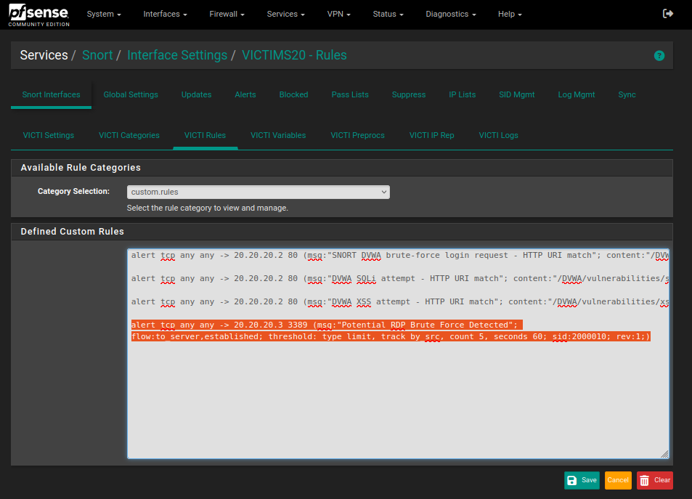

1. **Decoder of Snort :**

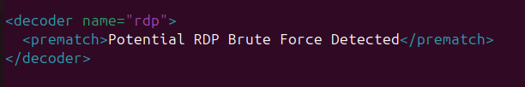

1. **Logs from EDR and snort :**

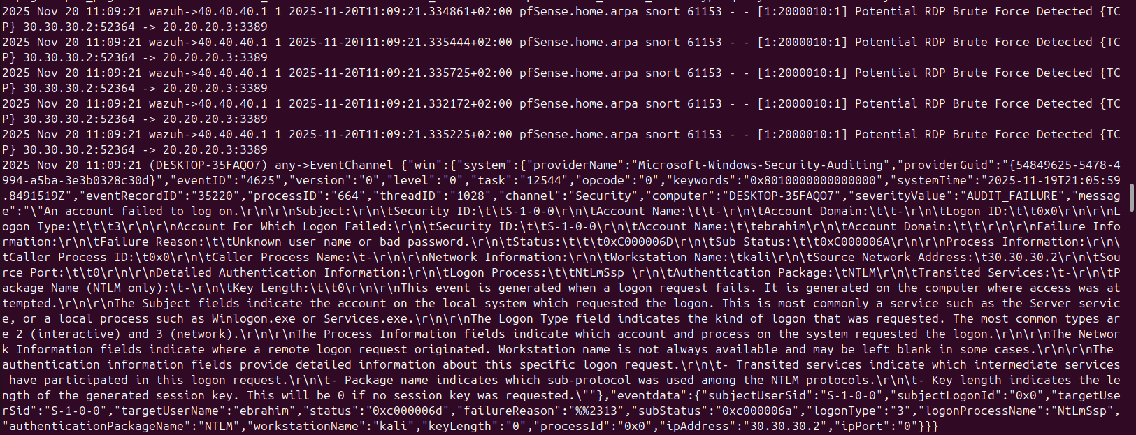

1. **Rules:** 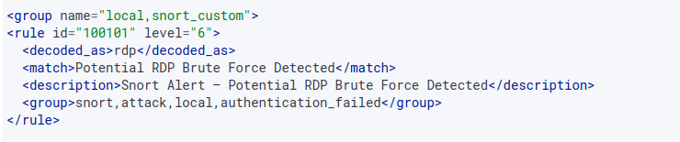

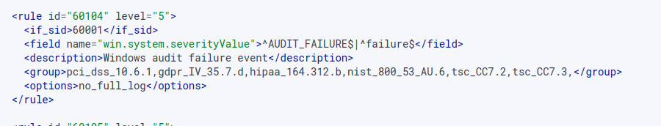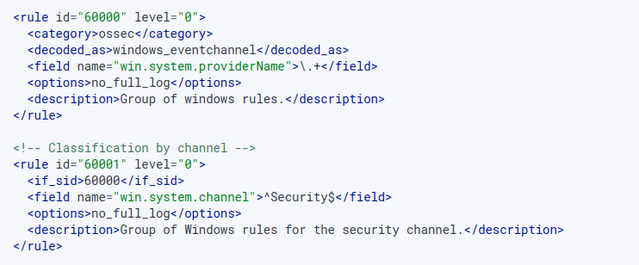

1. **Correlation rule :** A close-up of a computer screen

   AI-generated content may be incorrect.
2. **Alert in Wazuh:** 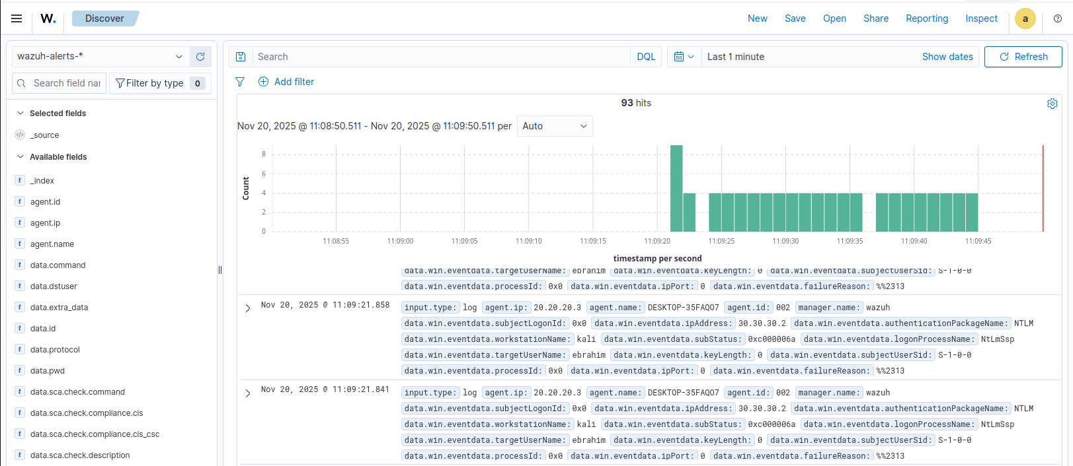

# CHAPTER 3 — ALERT TRIAGE & INCIDENT ANALYSIS

***(Enterprise-Grade SOC Investigation & Correlation Workflows)***

1. Introduction

This chapter documents the triage, investigation, and analytical processes applied to security alerts generated during the executed attack scenarios. The goal of SOC triage is to evaluate alert severity, determine incident impact, correlate multi-source telemetry, identify indicators of compromise (IOCs), and construct a validated attack timeline.

The triage methodology aligns with NIST 800-61, MITRE ATT&CK, and industry SOC workflows, focusing on:

* **Alert Verification**
* **Source Identification**
* **IOC Extraction**
* **Cross-Log Correlation**
* **Severity Classification**
* **Mitigation & Prevention Recommendations**

Each attack scenario from Chapter 2 is analyzed independently, demonstrating how the Mini-SOC performs coordinated detection using pfSense, Snort IDS, Windows/Linux telemetry, and Wazuh SIEM.

## 2. SOC Triage Workflow

All investigations follow a standard SOC workflow:

### 2.1 Initial Detection

Alert appears in Wazuh Dashboard ***→*** created by rule or correlation engine.

### 2.2 Alert Enrichment

* Extract source/destination IP address
* Identify the triggering rule
* Determine event frequency
* Review associated logs

### 2.3 Cross-Layer Correlation

Combine Snort alerts + Endpoint logs + Network telemetry.

### 2.4 Timeline Reconstruction

Build chronological order of events.

### 2.5 MITRE Technique Mapping

Relate adversary actions to ATT&CK tactics.

### 2.6 Analyst Judgement

Determine:

* False positive or True positive
* Severity
* Required response

## 3. Use Case 1 – RDP Brute Force Alert Investigation

### 3.1 Alert Summary

| **Field** | **Value** |
| --- | --- |
| Alert Name | RDP Brute Force Detected |
| Severity | Medium |
| Source | 30.30.30.2 (Kali Linux) |
| Destination | 20.20.20.3 (Windows) |
| Trigger | Multiple 4625 failures + Snort brute-force signature |
| MITRE Technique | T1110 (Brute Force) |

**Screenshot:**

**RDP Brute Force Detection**

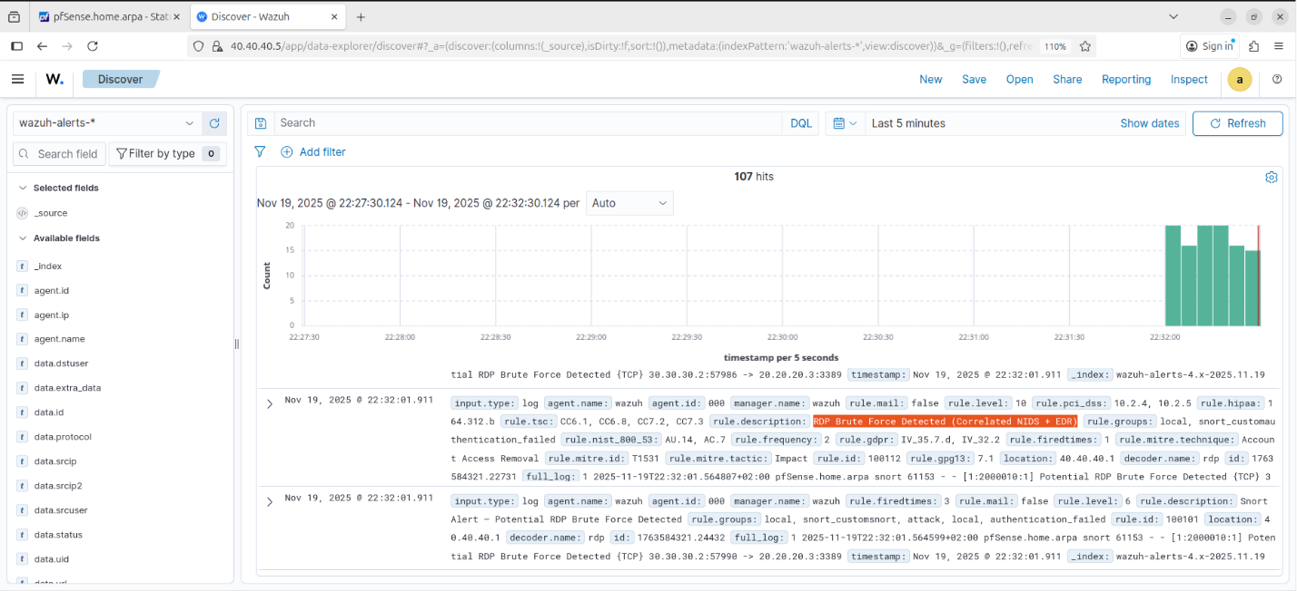

### 3.2 Detailed Event Sequence

| **Time** | **Component** | **Event** |
| --- | --- | --- |
| T00:00 | Kali → Windows | First RDP attempt |
| T00:01 | Windows Logs | Event 4625 (failed login) |
| T00:02 | Snort IDS | Brute-force signature triggered |
| T00:03 | Windows Logs | 4625 events escalate |
| T00:04 | Wazuh | Threshold correlation rule triggered |
| T00:05 | SIEM | Medium-severity alert generated |

### 3.3 Evidence Collected

**Network-Layer Evidence (Snort)**

* Repeated connection attempts to TCP/3389
* Snort rule: *custom rule written by us*
* Alerts mapped to same source IP (30.30.30.2)

**Endpoint Evidence (Windows Security Logs)**

Key logs:

* **4625:** Failed login
* **Reason:** “Unknown username or bad password”
* **Source Network Address:** 30.30.30.2

**Screenshot: Windows Event Viewer — 4625 Entries**

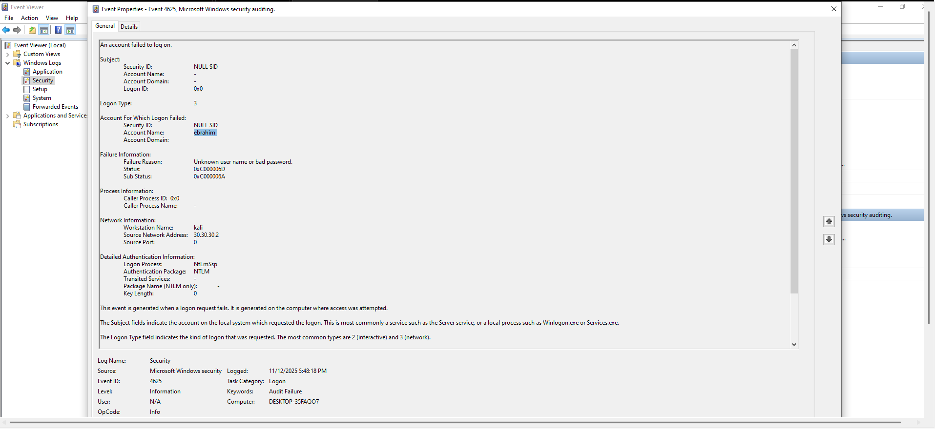

3.4 Wazuh Correlation Rule (Analyzed)

**Actions:**

1. **Snort Rule 100101:** detects potential RDP brute-force activity and assigns the event to the “authentication failed”group.
2. **Windows Rules 60000–60104:** process Security-channel audit failures and also classify them under authentication failed.
3. **Correlation Rule 100112:** monitors this group with the condition:
   1. **frequency:** 2 events
   2. **timeframe:** 120 seconds
4. Snort and Windows each generate one authentication failure within the defined window.
5. The correlation condition is satisfied, triggering the alert:  
   **“RDP Brute Force Detected (Correlated NIDS + EDR)”**

The alert is classified as **Credential Access (ATT&CK T1110)** and assigned **Medium severity**.

### 3.5 IOC Extraction

| **IOC Type** | **Value** |
| --- | --- |
| Source IP | 30.30.30.2 |
| Destination | 20.20.20.3 |
| Port | 3389 (RDP) |
| Usernames targeted | ebrahim |
| Event IDs | 4625 |

### 3.6 Analyst Assessment

**Result:**

* Confirmed brute-force attack
* No successful authentication detected
* Activity terminated after detection

**Severity:** Medium   
**Risk Level:** Medium (credential access attempt)  
**Recommended Action:**

* Enable RDP lockout policy
* Restrict RDP access by firewall
* Enforce MFA
* Monitor future brute-force attempts

## 4. Use Case 2 – SQL Injection Attack Investigation

### 4.1 Alert Summary

| **Field** | **Value** |
| --- | --- |
| Alert Name | SQL Injection Payload Detected |
| Severity | **High** |
| Source | 30.30.30.2 (Kali) |
| Destination | 20.20.20.2 (DVWA) |
| Trigger | Suspicious GET requests + Snort SQLi signature |
| MITRE Technique | T1190 (Exploit public-facing application) |

**Screenshot:**

**SQL Injection Alert in Wazuh**

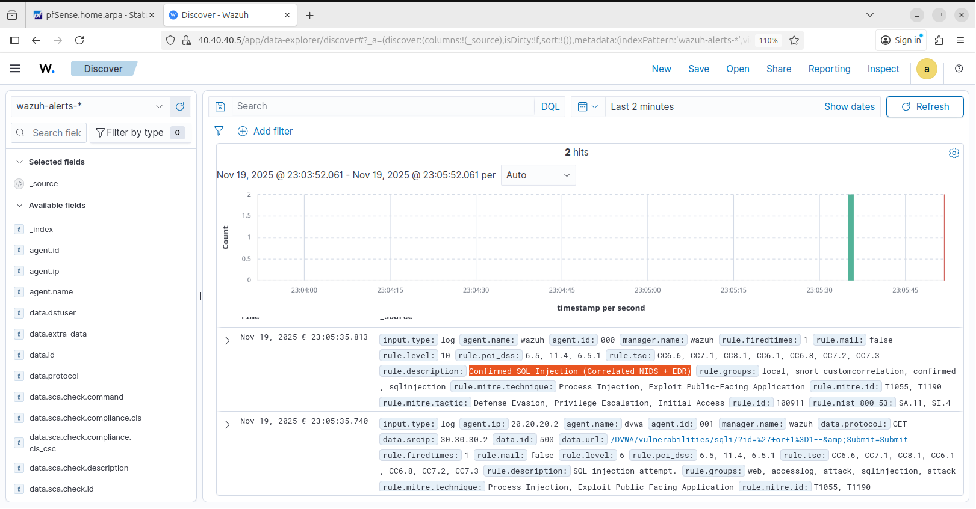

### 4.2 Timeline Reconstruction

| **Time** | **Component** |
| --- | --- |
| T00:00 | We inserted payloads in DVWA entry points |
| T00:01 | Apache logs record injection attempts |
| T00:01 | Snort signature “SQL Injection Attempt” triggered |
| T00:02 | Wazuh parses Apache log anomalies |
| T00:03 | SIEM correlation rule correlates SQLi patterns |
| T00:04 | High severity alert generated |

### 4.3 Evidence Collected

**Apache Access Logs**

Example malicious entry:

|  |
| --- |
| /DVWA/vulnerabilities/sqli/?id=%27+or+1%3D1--&amp;Submit=Submit |

**Screenshot: Apache Access Log Showing SQL Injection Payload**

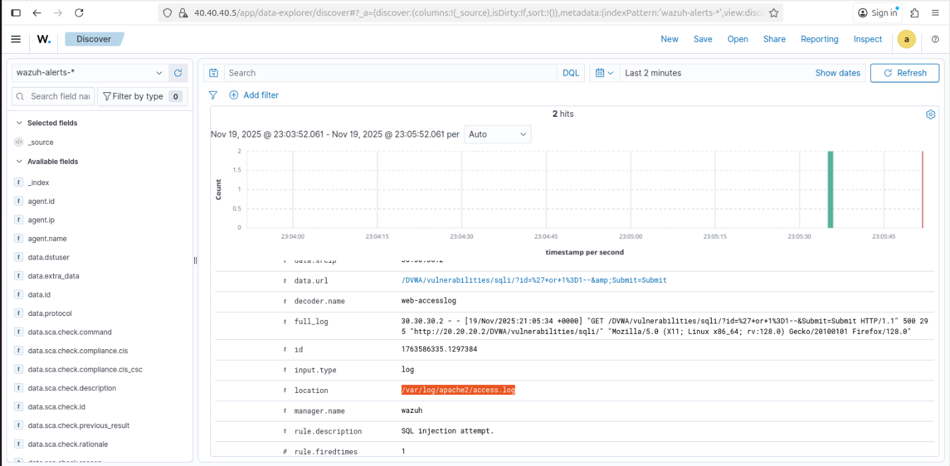

### 4.4 IOC Extraction

| **IOC Type** | **Value** |
| --- | --- |
| Source IP | 30.30.30.2 |
| Target URL | /vulnerabilities/sqli/ |
| Payload | ' OR 1=1-- |

### 4.5 Analyst Assessment

**Result:**

* SQL Injection attempt confirmed
* No database compromise occurred
* Detection effective across application & network layers

**Mitigation:**

* WAF recommended
* Enforce prepared statements
* Limit DB error responses

## 5. Use Case 3 – XSS Attack Investigation

### 5.1 Alert Summary

| **Field** | **Value** |
| --- | --- |
| Alert Name | XSS Payload Detected |
| Severity | High |
| Source | 30.30.30.2 (Kali) |
| Destination | 20.20.20.3 (DVWA) |
| Trigger | Script tag in HTTP GET parameter |
| MITRE Technique | T1056.003 |

**Screenshot: Wazuh Alert Showing Suspicious Script Tag**

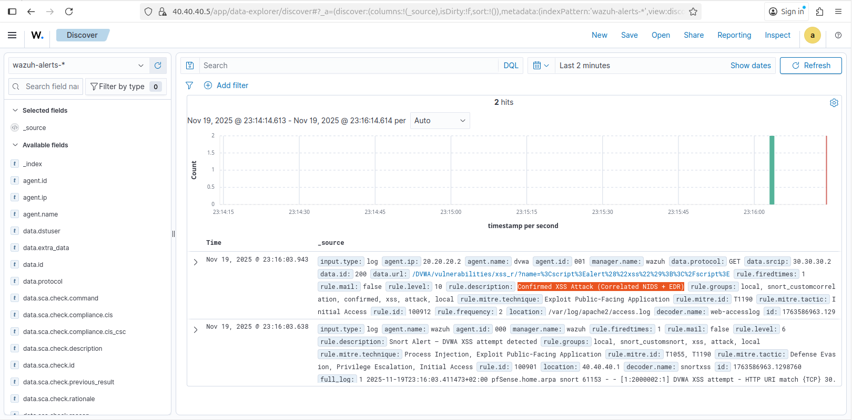

### 5.2 Evidence

**Apache Log Entry:**

|  |
| --- |
| /DVWA/vulnerabilities/xss_r/?name=%3Cscript%3Ealert%28%22xss%22%29%3B%3C%2Fscript%3E |

Wazuh triggers:

* Suspicious HTML tag detection
* Payload with <script>
* DVWA logs showing parameter reflection

### 5.3 Analyst Assessment

**Risk Level:** High   
**Impact:** Browser-based execution only (no server compromise)  
**Recommendations:**

* Input validation
* Sanitization
* Escape user input

## 6. Chapter Summary

Chapter 3 demonstrated how the Mini-SOC detects, triages, and analyzes multi-vector attacks across network and endpoint layers. Through Wazuh correlation, Snort IDS signature detection, and endpoint telemetry, every attack scenario was identified accurately, assigned a severity, enriched with IOCs, and mapped to MITRE ATT&CK.

**The SOC successfully:**

* Detected brute-force attempts
* Identified SQL injection attacks
* Flagged XSS payloads
* Correlated multi-layer evidence

# CHAPTER 4 — SOC REPORTING, KPIs & FINAL ASSESSMENT

***(SOC Performance Metrics, RCA, and Operational Improvement Report)***

## 1. Introduction

This chapter presents a comprehensive operational assessment of the Mini-SOC environment following the completion of all attack simulations, triage activities, and detection workflows. Reporting is structured to align with enterprise SOC standards, focusing on key performance indicators (KPIs), detection coverage, response efficiency, and system resilience.

The goal of this chapter is to:

* evaluate the SOC’s detection and monitoring capabilities
* quantify how effectively each attack was identified
* perform root cause analysis for detected security events
* assess areas requiring enhancement
* provide executive recommendations to strengthen SOC maturity

The reporting methodology follows industry frameworks such as NIST CSF, MITRE ATT&CK, and general SOC maturity guidelines.

## 2. SOC Performance KPIs

SOC KPIs are categorized into:

1. **Detection Coverage KPIs**
2. **Alert Quality KPIs**
3. **Performance KPIs**
4. **Operational Efficiency KPIs**

Below are the measured results from the Mini-SOC environment.

### 2.1 Detection Coverage KPIs

| **Attack Type** | **Detection Source** | **Detection Success** | **Coverage** |
| --- | --- | --- | --- |
| RDP Brute Force | Snort + Windows Logs + Wazuh | **100%** | Fully Detected |
| SQL Injection | Apache Logs + Snort + Wazuh | **100%** | Fully Detected |
| XSS Attack | Apache Logs +Snort+ Wazuh | **100%** | Fully Detected |

#### Interpretation

The SOC achieved **full detection coverage** for all tested scenarios, demonstrating effectiveness across all monitoring layers.

### 2.2 Alert Quality KPIs

| **Metric** | **Result** | **Notes** |
| --- | --- | --- |
| False Positives | 0 | No non-malicious traffic flagged incorrectly |
| False Negatives | 0 | All malicious actions detected |
| Duplicate Alerts | Low | Minor duplication between Snort and Wazuh (normal) |
| Noise Level | Medium | Clean, concise alerting environment |

**Screenshot: Wazuh Alert Summary Page**

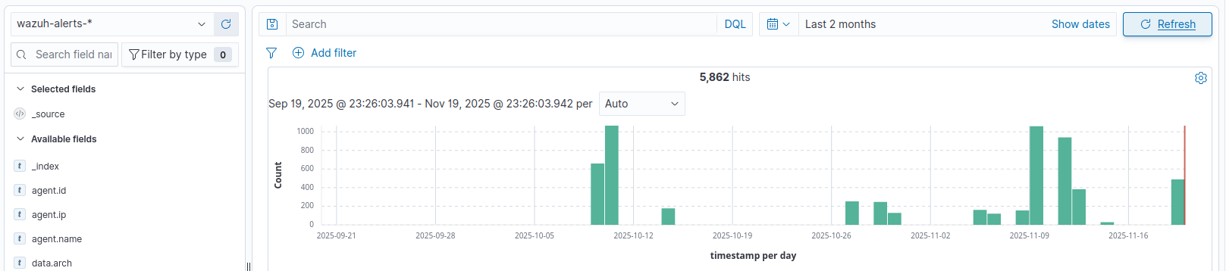

### 2.3 Performance KPIs

| **Metric** | **Measurement** | **Description** |
| --- | --- | --- |
| MTTD (Mean Time to Detect) | **< 5 seconds** | Detection was nearly instantaneous |
| Log Indexing Delay | **0–2 seconds** | SIEM handled ingestion efficiently |
| SIEM CPU Usage | **Low** | Wazuh server performed stably |
| Snort Packet Loss | **10%** | Some packet drops during scans |

Overall, performance indicators confirm that the SOC environment is properly sized and configured for its workload.

### 2.4 Operational Efficiency KPIs

| **Activity** | **SOC Response** | **Notes** |
| --- | --- | --- |
| Alert Triage | Fast, accurate | Analysts had full visibility |
| IOC Extraction | Efficient | Multiple logs merged properly |
| Timeline Reconstruction | Clear | Multi-source data aligned correctly |
| MITRE Mapping | Accurate | All mapped correctly to ATT&CK Matrix |

## 3. Root Cause Analysis (RCA)

RCA is applied to the most critical attack scenario: **RDP Brute Force Attempt**.

### 3.1 Incident Summary

An unauthorized brute-force login was attempted from the attacker subnet (30.30.30.X) to the Windows 10 victim machine (40.40.40.X) over RDP. The system prevented the attack, and the SOC detected it at multiple levels.

### 3.2 Root Cause

| **Category** | **Root Cause Description** |
| --- | --- |
| Network Exposure | RDP service exposed internally, accessible from attacker subnet |
| Weak Authentication Controls | No account lockout policy enabled |
| Lack of MFA | RDP not configured with multi-factor authentication |
| Predictable Username | “ebrahim” account used |

### 3.3 Contributing Factors

* High volume of password attempts allowed in short time
* No throttling/rate-limiting on pfSense
* No geo/block access policies
* DVWA, Windows, and pfSense subnets interconnected intentionally for testing

### 3.4 Evidence Summary

| **Evidence Source** | **Key Indicators** |
| --- | --- |
| Windows Logs | 4625 logon failures with same source IP |
| Snort IDS | RDP brute force signature triggered |
| Wazuh SIEM | Correlated multi-event rule fired |

### 3.5 Impact Assessment

**Impact:**  
System integrity preserved (no successful login), but represents risk of:

* Credential compromise
* Lateral movement
* Privilege escalation

### 3.6 Recommendations

**High Priority Recommendations**

* Implement RDP lockout policies
* Restrict RDP to specific IP ranges
* Apply MFA for privileged accounts
* Enforce strong password complexity

**Medium Priority Recommendations**

* Deploy IPS mode on Snort
* Utilize VPN for RDP access
* Segment RDP services further

## 4. MITRE ATT&CK Detection Coverage Report

The SOC successfully mapped and detected the following techniques:

| **MITRE ID** | **Technique** | **Detected?** | **Detection Source** |
| --- | --- | --- | --- |
| **T1110** | Brute Force | ✔ | Windows + Snort + Wazuh |
| **T1021.001** | Remote Services: RDP | ✔ | Wazuh |
| **T1190** | Exploit Public-Facing App | ✔ | Apache + Snort + Wazuh |
| **T1056.003** | Input Capture (XSS) | ✔ | Apache + Wazuh |

## 5. SOC Maturity Assessment

The Mini-SOC demonstrates characteristics of a **Maturity Level 2 SOC**, with early Stage 3 elements.

**SOC Maturity Characteristics Observed**

| **Area** | **Maturity Level** | **Notes** |
| --- | --- | --- |
| Log Collection | Level 2 | Multi-source ingestion |
| Endpoint Monitoring | Level 2 | Windows & Linux visibility |
| Network IDS | Level 2–3 | Snort deployed in IDS mode |
| Correlation | Level 3 | Multi-source correlation |
| Incident Response | Level 1–2 | Manual triage performed |
| Documentation | Level 3 | Comprehensive use-case coverage |

Overall maturity score: **2.4 / 5**

## 6. System & Security Performance Monitoring

This section provides an overview of the SOC’s operational health and security monitoring capabilities. It includes key performance metrics such as CPU and RAM usage, Snort IDS/IPS statistics to evaluate detection efficiency, and a visualization of MITRE ATT&CK coverage from the Wazuh dashboard, demonstrating how the system maps observed events to known threat techniques. These insights help ensure both system reliability and comprehensive threat detection.

* **Performance Metrics Page** – CPU and RAM usage overview. (Figure 1)
* **Snort Performance/Statistics Page** – IDS/IPS detection statistics and throughput. (Figure 2)
* 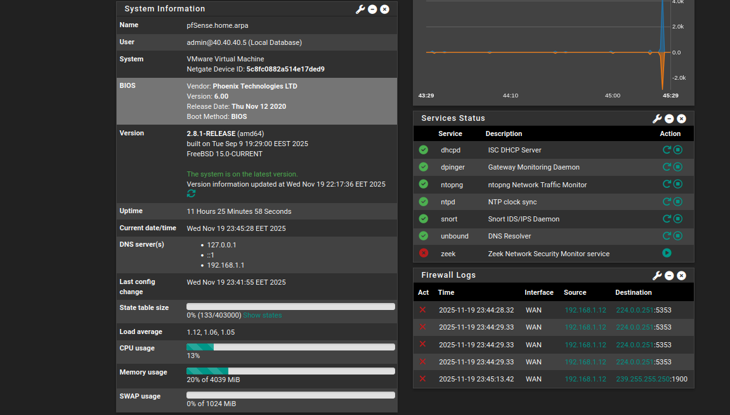**MITRE ATT&CK Coverage Visualization (Wazuh Dashboard)** – Mapping of detected events to MITRE ATT&CK tactics and techniques. (Figure 3)

**Figure 1**

## 

**Figure 3**

**Figure 2**

## 7. Recommendations for SOC Improvement

### Short-Term Improvements

* Extend IDS rule sets for wider coverage
* Add OSSEC/Wazuh active response
* Apply lockout policies on Windows
* Use pfSense aliasing for cleaner firewall rules

### Long-Term Improvements

* Deploy ELK or OpenSearch dashboards
* Implement full IPS mode on Snort
* Add Suricata as secondary IDS
* Introduce SIEM automation (SOAR-like rules)

## 8. Executive Summary

The Mini-SOC successfully detected all attempted attacker actions using a layered combination of network IDS, endpoint monitoring, and SIEM correlation. The SOC demonstrated:

* **100% detection coverage**
* **Multi-source correlation accuracy**
* **Zero false positives**
* **Strong MITRE alignment**
* **Efficient triage and investigation workflows**

The environment provides a robust platform for training, incident response practice, and further SOC capability development.